1. The Normal (Gaussian) Distribution
The normal (or Gaussian) distribution is a continuous probability distribution that frequently occurs in nature and has many practical applications in statistics. Many of its statistical uses derive from the fact that random errors often follow a normal distribution. We will be using the normal distribution and its relatives a great deal in the remainder of the course.

 | 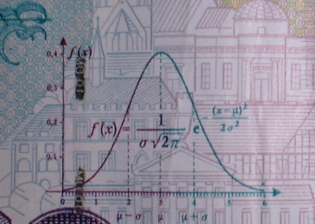

Carl Friedrich Gauss (1777–1855)

Watch video: Ball Bearing Experiment (Demonstrates Normal Distribution)
http://www.youtube.com/watch?v=AjI_LcQOOs4

Examples of Normally Distributed Phenomena

- Human height
- Human intelligence (IQ)
- No. of defective parts in a batch of 1000
- Voltage output of a battery
- Strength of a steel girder

In general, a normal curve occurs in processes which reflect the accumulation of many sources of random variation.

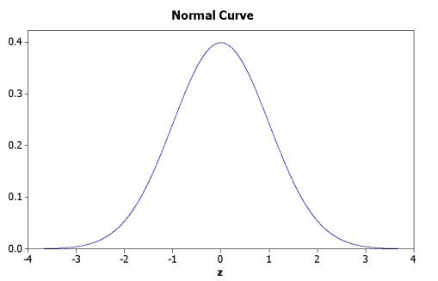
Characteristics of a normal distribution

- Bell-shaped appearance
- Symmetrical
- Unimodal
- Mean = Median = Mode
- Described by two parameters: mean (μ_{x}) and standard deviation (σ_{x})
- Theoretically infinite range of x: (-inf < x < +inf)

The normal distribution is described by the following formula:

where the function f(x) defines the probability density associated with X = x. That is, the above formula is a probability density function (pdf; see previous lecture)

2. The Standard Normal Distribution

Because μ_{x} and σ_{x} can have infinitely many values, it follows there are infinitely many normal distributions:

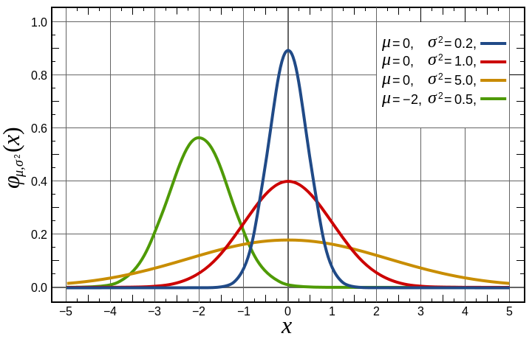

Yet they all have the same shape. Therefore all normal distributions can be rescaled into a standard form by a simple linear transformation (adding a constant and multiplying by a constant). The result is the standard normal distribution. A standard normal distribution is a normal distribution rescaled to have μ_{x} = 0 and σ_{x} = 1. The pdf is:

The ordinate of the standard normal curve is no longer called x, but z.

Standardizing a normal distribution facilitates the computation of areas under various regions of the curve. Such calculation of areas (which correspond to various probabilities of interest) is an essential task in statistics and quality control.

For a normal curve, approximately 68.2%, 95.4%, and -99.7% of the observations fall within 1, 2, and 3 standard deviations of the mean, respectively.

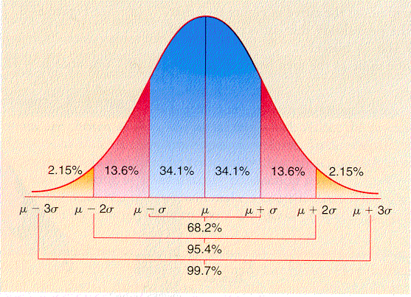
Areas Under the Normal Curve

By standardizing a normal distribution, we eliminate the need to consider μ_{x} and σ_{x}; we have a standard frame of reference.

Areas Under the Standard Normal Curve

X (x values) of a normal distribution map into Z (z-values) of a standard normal distribution with a 1-to-1 correspondence.

If X is a normal random variable with mean μ_{x} and σ_{x}, then the standard normal variable (normal deviate) is obtained by:

 | (x – μ_{x} )
z = | –––––
 | σ_{x}

Normal Cumulative Distribution Functions

Previously people used tables to compute the probability of a normally distributed x- or z-score falling in a certain range. Now statistical software does this using built-in cumulative probability distribution functions for the standard normal and normal curves.

cdf(z) = probability of –inf. < Z < z

Inverse Cumulative Distribution Functions

Sometimes we are interested in the reverse problem: to find the x- or z-score such that the proportion of all values lower than this is p. For this statistical software has built-in inverse cumulative probability distribution functions.

cdf_{z} ^{–1}(p) = z score such that Pr(-inf < Z < z) = p.

Normal and Standard Normal Distribution Functions in Excel

Regular functions (score to probability)

NORM.DIST(x, mean, std. dev., cumul)
Area of normal distribution from –inf to x.

x = user supplied value
mean = mean of distribution
std. dev. = standard deviation of distribution
cumul: 0 = no (gives probability density),
1 = yes (gives cumulative density, i.e., area)

NORM.S.DIST (z, cumul)
Area of standard normal distribution from –inf to z.

z = user supplied value
cumul: 0 = false (gives probability density),
1 = true (gives cumulative density, i.e., area)

Inverse functions (probability to score)

NORM.INV (p, mean, std. dev)
Supplies x value such that area from –inf to x = probability p.

p = cumulative probability of x (area from –inf to x)
mean = mean of distribution
std. dev. = standard deviation of distribution

NORM.S.INV (p)
Supplies z value such that area from –inf to z = probability p.

p = cumulative probability of x (area from –inf to x)

Example 1

Assume that for all SAT scores the mean = 1509 and std. deviation = 312. What proportion of SAT scores falls below 1850?

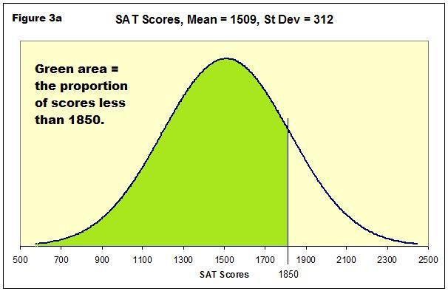

Answer:

Pr(x < 1850) = NORM.DIST(1850, 1509, 312, false) = 0.863

Example 2

What is the probability that Z falls z = 1.11 and z = 2.34? (Hint: you will need to calculate cumulative area twice, and subtract the larger from the smaller area.)

Answer:

Pr(1.11 < z < 2.34)
= area from z = 2.34 to z = 1.11
= area from (–inf to z = 2.34) minus area from (-inf. to z = 1.11)
= NORM.S.DIST (2.34, true) – NORM.S.DIST(1.11, true)
= .9904 – .8665 = .1239

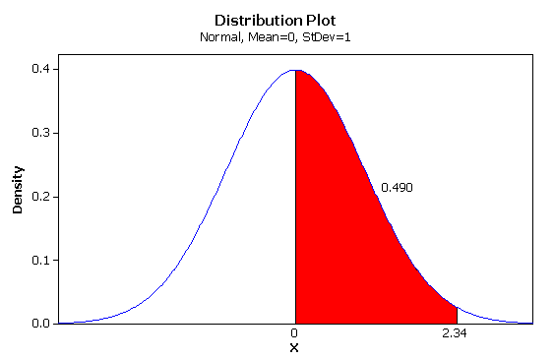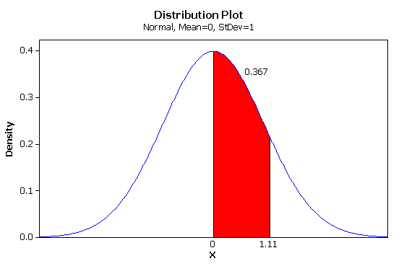
Note: figures above should also shade region from –inf to 0.

Example 3

Find z is such that P(Z < z ) = 0.80; i.e., find the 80th percentile (area from =inf to z is .80).

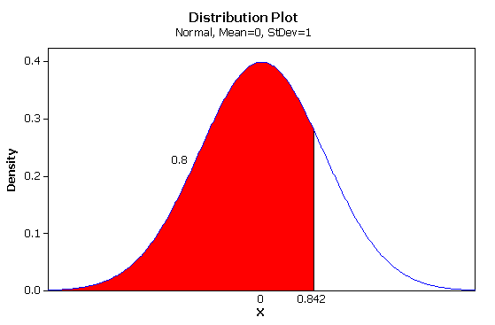
Answer:

NORM.S.INV (.80) = .8416

Videos:

jbstatistics: An Introduction to the Normal Distribution
http://www.youtube.com/watch?v=iYiOVISWXS4

jbstatistics: Standardizing Normally Distributed Random Variables (first 2 mins.)
http://www.youtube.com/watch?v=4R8xm19DmPM

Homework:

1. Read pp. 184–191 (but ignore all specifics concerning use of Normal Curve Tables.).

2. Download from class website the Excel spreadsheet Normdist.xlsx.

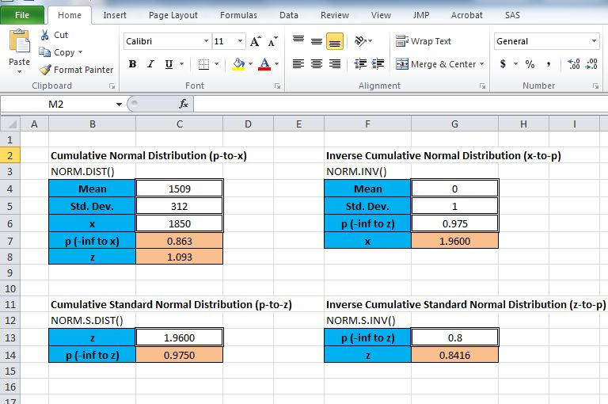

This spreadsheet contains four calculators: two for computing areas under the normal and standard normal curves, and two for determining x or z scores given a cumulative area.

3. Using the spreadhseet calculators, work problems:
– 5.6 a(1) and a(2)
– 5.6 b
– 5.6d

